Installing Drools on Tomcat

Download drools-5.0-guvnor from the JBoss website at http://www.jboss.org/drools/downloads.html

Unpack it, and copy the drools-guvnor.war file to the Tomcat webapps directory

Download jboss_jsf_libs.zip from http://download.jboss.org/drools/dependencies/jboss_jsf_libs.zip

Unpack it, and copy the 3 libraries to C:\Program Files\Apache Software Foundation\Tomcat 6.0\webapps\drools-guvnor\WEB-INF\lib
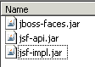

Run http://localhost:8080/drools-guvnor/ and you will get this login screen
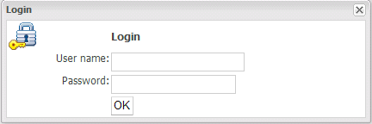

Leave the ID and Password blank and just click the OK button

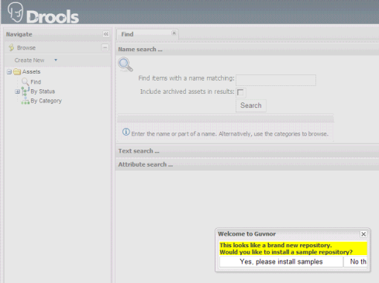

Click on “Yes, please install samples”
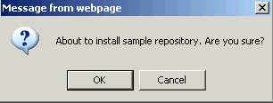

Click on “OK” and you will get a confirmation that repository was installed successfully

You now have Drools running under Tomcat…

